Curriculum Vitae
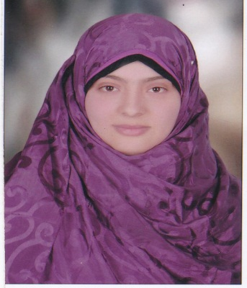
Name: Seham Mohamed Anwar Demais
Position: Demonstrator
Birth Day: 17/01/1991
Birth Place: Markaz AR Rahmaneyah, El Beheira Governorate, Egypt
Email Address: seham.anwar@fagr.bu.edu.eg
Graduate date: 2013
Department: Genetics and genetic engineering
Faculty of Agriculture/ Benha University/ Egypt
Degree: B.Sc. In agri. sciences (Genetics and genetic engineering)
Gender: Female
Master Degree title: Genetic studies on some crosses between hexaploid and tetraploid wheat

